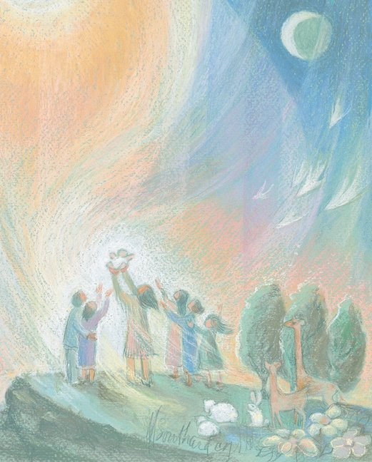
"Behold, behold, this new born one!
Let us nurture and keep alive
the sacred mystery of hope
hallowed in this young one's heart.
We sow our dreams of a future
in this freshly birthed being.
We give our loving promise
to guide and guard this child.
Always we will remember
our oneness in the dancing cosmos.”
Joyce Rupp

Dear Sisters, Associates and friends,
Loving greetings to all. It is so nice to get in contact with all of you again!
In Peru, the government declared 2011 to 2020 as the “decade of people living with disabilities” and 2012 as the "year of national integration and appreciation of our diversity". Although there is a general law for people with disabilities, which promotes their rights and protection, we are far from what is written there. Disability remains a factor that aggravates the extreme poverty of many families.
This year we would like to share with you some stories that will give you a glimpse of our mission involvement with families that have children with disabilities.
COFARI - Community of Families and Comprehensive Rehabilitation
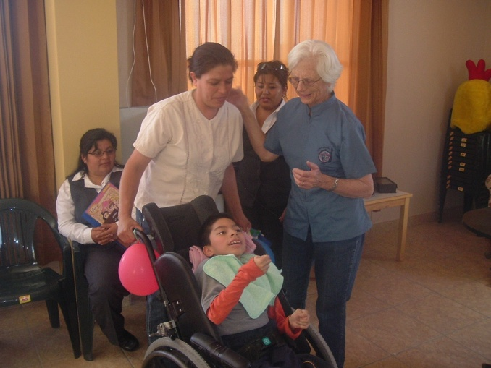
COFARI began in Arequipa ten years ago, in the house of the mother of a child with cerebral palsy. Around that time, I met two children who were two years old and had difficulties in gait and speech. They were not able to hold the weight of the head.
In that way, COFARI began with three children and after a year became eight. The room was very small and because of that, the parish gave us a larger environment. At that time, we were dreaming with the families of having our own place, where more children could come.
What happened was almost like a miracle, the City Council of Miraflores, in 2008, promised to build a place for us. In 2009, the promised was fulfilled and a beautiful building was given to us. I mean like a miracle, because I am convinced that all our children moved the heart of the people of the town hall.
We are now offering professional counseling, occupational therapy, hydrotherapy, psychology, speech therapy, balanced meals, and shuttle service to and from home. Most children come from families with low income and pay very little for the daily therapies. Due to that, COFARI functions thanks to foreign grants and local donations. So far, people generously help us.
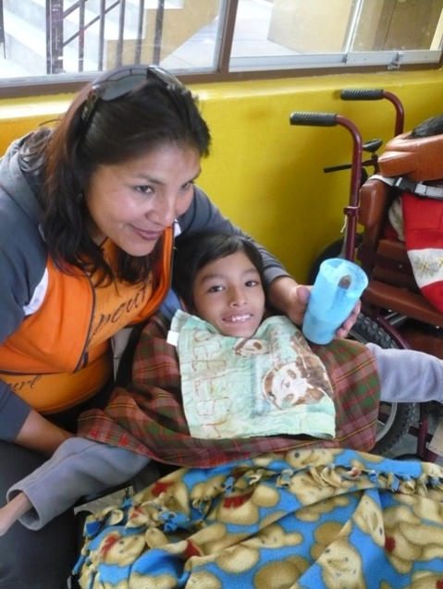
I would like to tell a little about Eduardo: Edu is five years old. He and his mother live in a strange house, which they care. Edu has cerebral palsy and mental retardation. He could not walk or talk, but answered with his eyes and smile. He requires daily therapies to reduce the spasms of his muscles and facilitate the mobility of his body.
The child stays in COFARI during the day and her mom has found a job to support the family. After having surgery, he is able to sit in a wheelchair. This is important, because he is growing and soon his mother will not be able to hold him. We hope that in one or two years of physical therapy and occupational therapy, Edu will be able to enter a special school and learn a trade that can support him in life.
Pat Gootee, MMS
The story of Heiner Yair Goicochea Tirado
Heiner is a 15 year old boy, who was born with “Split Spine” (a congenital spine disorder), and because of that, surgery and the placement of a valve, were needed.
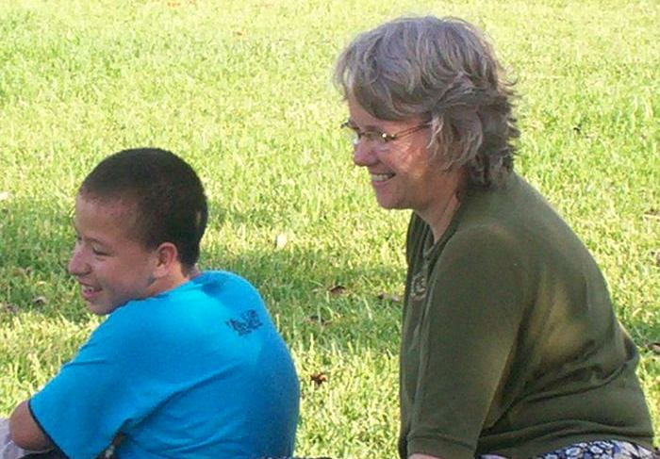
Shortly after his birth, his father abandoned them, and lived with his mother until the age of seven. Then, when care needs involved large expenses, his mother asked the father of the child to take responsibility, but he worked as a taxi driver and could not respond to that. Then, one of her aunts, named Estella, took him into her house. She is a good woman whom I know as an active member of the parish.
When Estella took charge of Heiner, he could not read or write and had a learning disability. When I met him, he was very shy and spoke little. He had to stay often in hospital due to different infections. Nonetheless, he was a smiling child and very patient.
Possibly for his kind personality, he could participate very well in catechesis for First Communion in the parish. The others treated him very well and smoothly integrated to the group. At that time, I realized that he could remember and sing the songs he learned in the parish. That is, could memorize, although he did not learn well when his aunt tried to teach him other things.
A volunteer psychologist evaluated him. She taught him a lot more than we thought was possible. Unfortunately, she became ill and could not help him anymore.
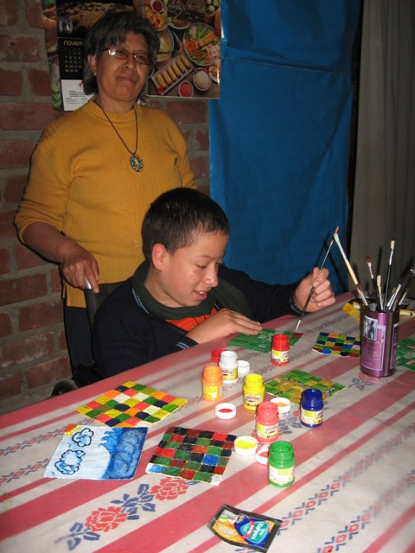
Heiner was growing fast and was too heavy for Estella to take care of. The family decided that the child should live in Trujillo (another city in Peru), with his dad. That was just when we were beginning to see small but significant advances in physical therapy and he began to seek more contact with other children. I felt very sad to interrupt this process of rehabilitation and talked to the aunt. Besides that, the child had had previous experience living with his dad, who has a new family. It was not a happy time for Heiner and even got sick.
When Estella realized the progress of Heiner and he was more and more independent and virtually could move by himself from the wheelchair to bed and back, she agreed to let him stay at her home and convinced his father that it was the best for him.
In the second part of 2010, the local government started a literacy project in the community center of the neighborhood (Bocanegra). He was willing to be part of the students, even though most are adults, not left off by this. He was given an assignment’s notebook and we could see his progress and support him as necessary.
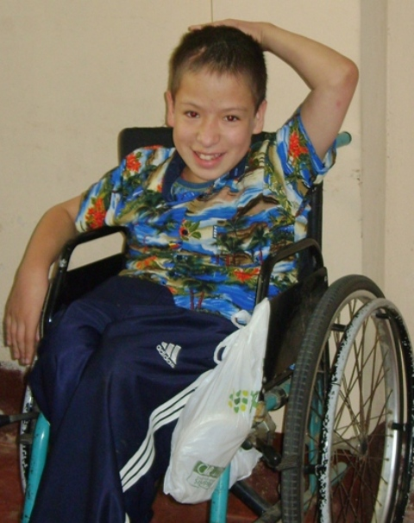
Once a week, he comes to physical therapy in our project, where he has also contact with other children. We have noticed that he speaks more and still seeks contact with children who are more disabled than he. It is very nice to see that.
He has grown so much that last year his wheelchair became very small. Fortunately an Association (United Hearts) donated another one for him.
Tomasa (HMM), who is a teacher, has visited Heiner regularly and encouraged him to do handicrafts to sell and earn a little income. He needed a lot of support but succeeded. Now he is also participating once a week in making handicrafts with other children and parents of the group receiving physical therapy in our project.
At home, Heiner has some responsibilities. He Participates and is well integrated into the Estella’s family.
For me, Heiner is a beautiful example of how therapy can let the kids to be more independent and this makes life easier for the family. It shows me also how much can be accomplished when the families take advantage of the opportunities that arise and get involved in the local community. We continue, day by day, walking with Heiner and his family.
Christianne Gadiot, MMS
The story of Nimia and her family: A story of faith
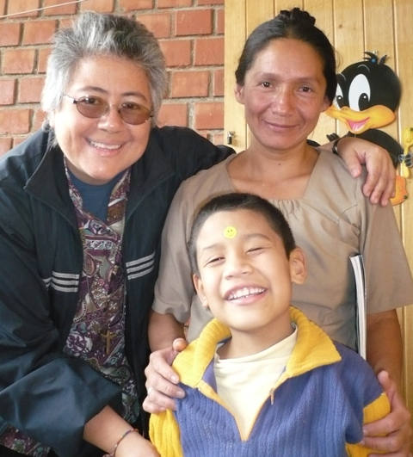
It is the dawn of a cold winter morning and not easy to get out of bed and take the long way to Pachacutec, almost two hours away from our community in Callao. However, when I remember the families that I meet each day there, it makes me feel blessed for sharing part of my life with them. There are so many stories I would like to tell you but I've chosen one.
It is 4:30 in the morning and the day begins for Nimia. She must prepare breakfast for the family. Her husband leaves very early to work as a guard at an elegant Spa in one of the richest areas of Lima; her second child leaves to go to the school and she has to bring the other two children to theirs. Then, she cleans the house, cooks, picks up the kids, goes with them to receive the therapies, does homework with the kids, feed them again and put them to sleep. Not to mention that often attends meetings of the Association of Parents of children with disabilities and goes every day to church. Besides all that, she works embroidering fabric to help with family expenses. Her day is fully booked. No time to complain or for getting ill.
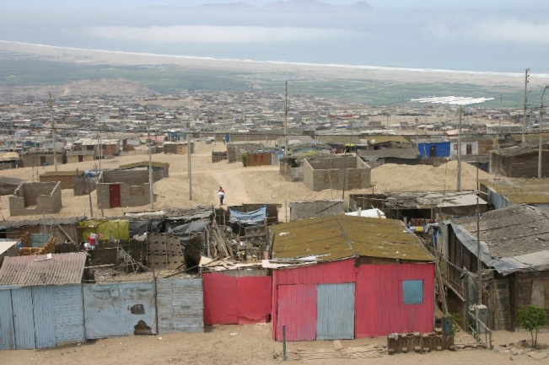
Nimia married Riester sixteen years ago. Since twelve years ago, the family lives in Pachacutec, one of the areas of extreme poverty in Callao. This slum is an isolated area, near the sea, exposed to extreme weather both in summer and in winter, devoid of all basic services for a decent life.
Their first child was Carolai, who was diagnosed with Cerebral Palsy at the age of eight months. She received therapies and medical care in different institutions of Lima and Callao, despite all the challenges that going out of Pachacutec with a child who could not move by herself, implied.
Three years after Carolai, Alonso was born. He does not have any developmental problem.
The third and youngest son is Jean Franco. A few months after his birth, they realized he had the same developmental problem that his sister. Because of that, Riester (the father) went into depression and did not assume household responsibilities well. He was unfaithful; complaining all the time and family life was very difficult.
Nimia began to seek help from institution to institution. That is how she came to us. She says that because of the reality of her children and the indifference of her husband, but above all her faith in God, became a strong woman, fighter, who also was involved in many community organizations to look for a better quality of life for all local families.
According to her, eventually her husband “met God” and began to see everything differently. He became an important support for his children and his wife.
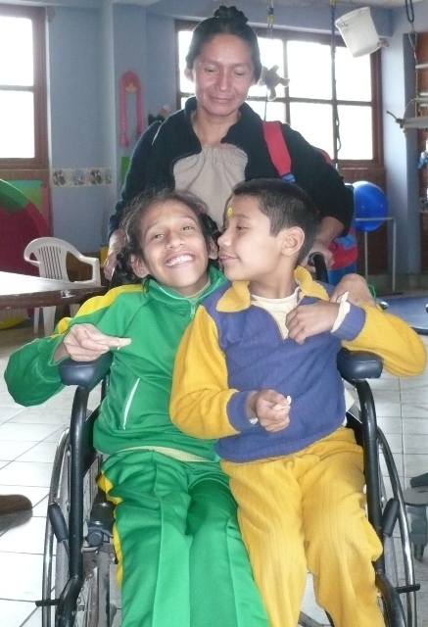
Nowadays, Jean Franco is almost eight. He is a beautiful child, very intelligent and smiling. He had slowly managed to talk, sit, stand, and soon he should start walking. His dream is becoming a Pastor, and enthusiastically attend their church activities (World Missionary Alliance). Jean Franco Prays a lot and cares about others going through difficult situations. He sometimes feels sad when cannot play soccer with other children or run with them but after a short while he is smiling again. He is included in a regular school, where the teachers, classmates and the school principal facilitate his integration in the classroom.
Alonso has not had an easy life at all. Being in the middle of his two siblings with special care needs, has had to take unusual responsibilities for a child. He early learned to assist his mother in housework and care for his brother and sister and still have time for his school work. He did not ask the attention and time that other children do. He kept from asking for unnecessary things and even some necessary, understanding that the family had only for the basics. Now, Alonso is 13 years and behaves like a little adult in the best sense of the word: Very mature, mindful, patient, calm and loving. He says he wants to be a doctor and devote his life to helping children with disabilities. I asked him what he could say about his life and responds: “It was not easy but what I can say is that I love my two siblings so much that I would give my life for any of them”. Alonso says that most people do not understand children with disabilities, they do not know how to treat them, are afraid to approach and only feel pity of them.
Carolai is a beautiful 16 years old lady, smiling and friendly. She was unable to walk and must therefore be taken in a wheelchair. The deformity of her spine is quite marked and this causes many problems. She loves to learn new things. She and her brother attend the therapies offered at our inter-Congregational, inter-organizational Community Based Rehabilitation program in Pachacutec. Also attends a public school for children with disabilities.
Thanks to the dedication, and loving care of their family, friends, people from their church and therapists, Jean Franco and Carolai have a better quality of life. It has been a continuous process of rehabilitation: a journey with many ups and downs. They had dealt with indifference, corruption, deception, poverty and discrimination. However, they also found solidarity, generosity, love and friendship.
I asked Nimia: What would you say to a mother that has just been told that her child has cerebral palsy? She responded: “Most importantly, do not be afraid. You are not alone. Many families live that situation. The main thing is that you feel accompanied by God and live with patience what each day brings. We learn to celebrate small accomplishments of our children and that will make your day. Do not despair. My best strategy is my faith”.
I feel privileged for being a witness of an experience like this. Their lives evangelize me. To accompany them in their daily struggle is a gift. It is a challenge to find how to be a healing presence in the midst of the extreme situations that life presents to them. I can feel a close and loving God, walking with them over the years. I think Nimia is a model of believing woman who enjoys life and small joys. Her life speaks of a beautiful friendship with the God of life.
Maria Fernanda Ramirez, MMS
Important Happenings in MMS Life during 2011 and 2012
So many reasons to celebrate…
2011
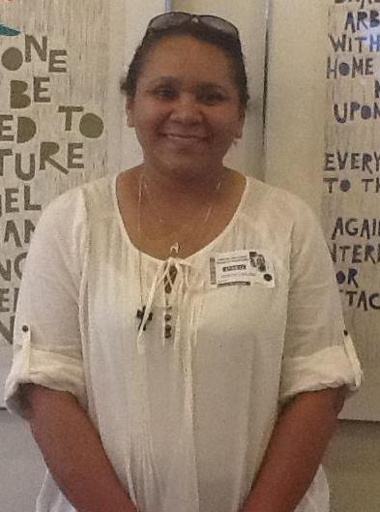
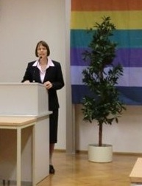
- In February, Birgit Weiler presented and defended her doctoral thesis in Frankfurt. Her focus of research was: “The mutual enrichment of indigenous cosmovision and Christian creation theology and spirituality." Because of her thesis, she received the Erwin-kräutler Reward - created by the University of Salzburg in honor to this Austrian Bishop who worked in Brazil, committed to the Indigenous people.
- In March, we celebrated 60 years of MMS healing presence in Venezuela
- In October, Norys Navas made her Final profession of Vows in Venezuela
- In December, Tomasa Martinez earned her Bachelor of Education
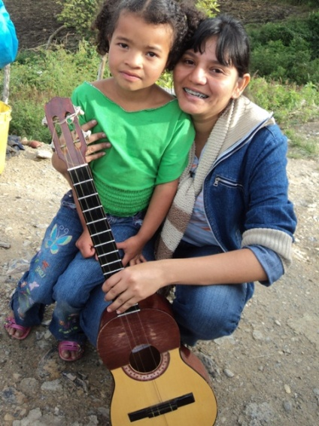
2012
- In January, Maidy Martinez made her First Vows in Barquisimeto-Venezuela
- In March, Renewal of Vows of Tomasa Martinez in Callao – Peru. During the same month, Diana Vasquez started her Aspirancy with MMS in Arequipa – Peru
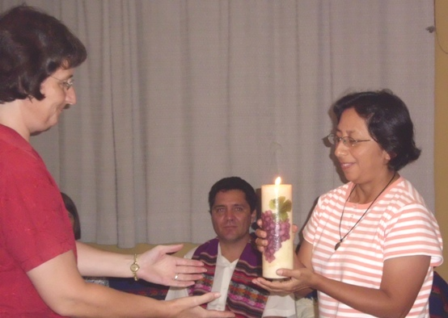
- In September, The parish Cristo Liberador in Callao, celebrated 25 years of existence. On the 30th we are going to celebrate our 87th foundation anniversary with different activities in Peru and Venezuela.
- In November, The group of volunteers from the Santa Maria University in Arequipa, will celebrate 10 years of existence. Therefore, they have organized a forum on "the mission of the volunteer" and a music festival.

Comings and goings…

2011

In April, Birgit Weiler came back to Peru
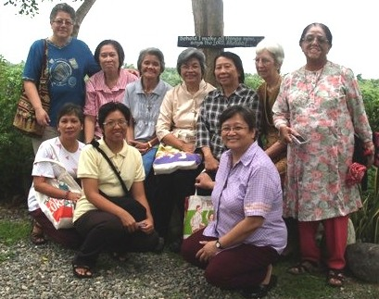
- In December, Maria Fernanda Ramirez came back to Peru after eleven months of international mission experience in the Philippines and a two weeks visit to our Sisters Philadelphia and Florida. Some days later, Norys Navas went to Philadelphia for Mission and English learning.

2012

In May, Emma Panizales attended the SEDOS annual meeting in London. The main topic was:"SPRING OF THE POOR?” - Latin America and the Caribbean - from Medellin to Aparecida.
- In July, Maria Salema went to India for a sabbatical year
- In August, Christianne Gadiot went to Holland for furlough. During the same month, Maidy Martinez moved from Barquisimeto to Caracas for a new mission and studies.
- In November, Norys Navas is coming back to Venezuela, after ten months in Philadelphia. We are very grateful with Sector North America for their support. During the same month, Aida Pelaez is leaving to the Philippines for furlough
New beginnings…
2011
- In October, for the first time, COFARI children in Arequipa (Project for disabled children) participated in a play on “dreaming of living integrated to the society”. It was very well received by the people. This is going to be once a year.
2012
- In March, Birgit Weiler started a new mission with the Jesuits in the Peruvian jungle. The purpose of the project is to review the experiences and establish the memory of the enculturation and evangelization process since sixties until today. That will be done together with people from two indigenous groups: Awarun and Wampis, in order to look into the future and to define how to accompany them in the coming years.
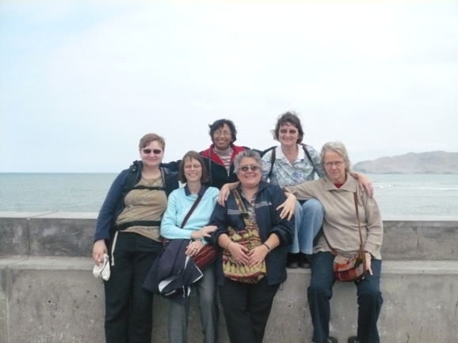
- During July and August, we enjoy the exposure of Monika Ballani from District Germany, in Peru. She shared our life in mission in Arequipa and Callao for six weeks. We are grateful to God, to District Germany and to Monika for such a significant experience.
- In September, MMS in Barquisimeto, together with the Jesuits and Sisters of reparation, organized spiritual exercises for youth who are discerning their life project. Fifteen Women and eleven men attended
- In December, donation of dairy products by Caritas Switzerland will come to an end. Women from that project would like to keep their organization. Therefore, they are going to make and sell handcrafts, in order to get some income for their families.
- During this year, MMS in Venezuela started the “League of solidarity”, where people are encouraged to participate in our mission through financial support. So far, there has been very good response.
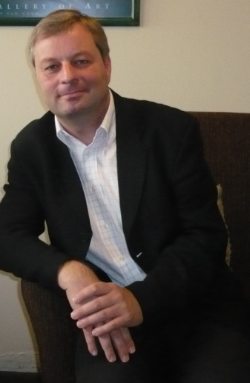
Visits
- At the end of July, Professor Dr. Dr. Franz Gmainer-Pranzl from the faculty of Catholic Theology of the University of Salzburg, and head of the committee that gave the Reward to Birgit last October - visited Peru.

We are grateful to God for his unconditional loving presence in our life in mission. We ask for your prayers so that we may keep the fire burning.

Yours, Maria Fernanda Ramirez (Editor) and all the MMS and Associates in Peru and Venezuela.

